The CPU generates **Logical addresses** when a programme is executing. Because the logical address does not exist physically, it is sometimes referred to as a virtual address. The CPU uses this address as a reference to reach a physical memory location. The set of all logical addresses created by a program's perspective is referred to as the Logical Address Space.

Memory-Management Unit is a hardware device that is used to translate logical addresses to physical addresses.

The **Physical Address** indicates the physical location of data in memory. The user is never directly dealing with the physical address, but rather with the associated logical address. The user programme creates the logical address and believes that the programme is executing in this logical address, but the programme requires physical memory for execution, therefore the logical address must be mapped to the physical address by MMU before it can be utilised. All physical addresses that correlate to logical addresses in a logical address space are referred to as Physical Address Space.

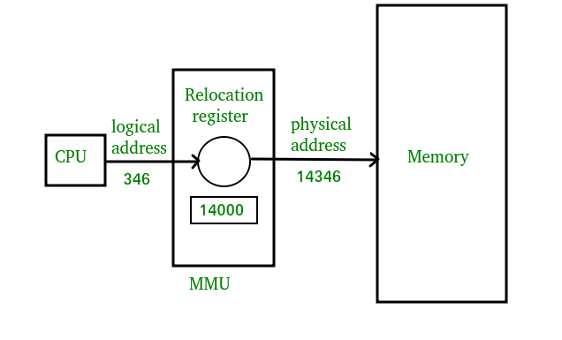

**Differences Between Logical and Physical Address in Operating System**

1. The primary distinction between logical and physical addresses is that logical addresses are created by the CPU in the context of a programme, whereas physical addresses are locations in the memory unit.
2. Logical Address Space is just the collection of all logical addresses created by the CPU for a programme, whereas Physical Address Space is the collection of all physical locations mapped to matching logical addresses.
3. The logical address does not exist physically in memory, but the physical address is a location in memory that can be physically accessed.
4. Compile-time and load-time address binding methods yield identical logical addresses; however, run-time address binding method generates different logical addresses.
5. The CPU generates the logical address while the application is executing, while the Memory Management Unit computes the physical address (MMU).

**Comparison Chart:**

|  |  |  |
| --- | --- | --- |
| **Parameter** | **Logical Address** | **Physical Address** |
| Basic | Generated by CPU | Location in a memory unit |
| Address Space | The logical address space refers to the collection of all logical addresses created by the CPU in relation to a programme. | Physical Address is a collection of all physical addresses that have been mapped to their matching logical addresses. |
| Visibility | |  |  | | --- | --- | |  | User can view the logical address of a program. | | User can never view physical address of program. |
| Generation | Generated by CPU | Computed by MMU |
| Access | The user can use the logical address to access the physical address. | The user can indirectly access physical address but not directly. |
| Editable | |  |  | | --- | --- | | Logical address can be change. |  | | Physical address will not change. |
| Also called | Virtual address | Real address |